What’s in this guide?
¿Que hay en esta guía?

Ways to vote
3 ways to vote | 2
How to vote by mail | 3
How to vote with a paper ballot | 4
How to vote with a touch screen ballot | 5
Accessible voting | 6
Who is on the ballot for this election | 7

Formas de votar
3 formas de votar, Cómo votar por correo, Cómo votar una boleta electoral de papel, Cómo votar una boleta electrónica, Votar con accesibilidad, Quién está en la boleta para esta elección | 8

What’s on the ballot for this election? | 14

¿Que hay en la boleta electoral para estas elecciones?
Party endorsements - Endosos de partido
About the candidates - Sobre los candidatos
Paid candidate statements - Declaraciones pagadas de los candidatos
Local ballot measures - Medidas electorales
Sample ballot – Muestra de Boleta

3 ways to vote
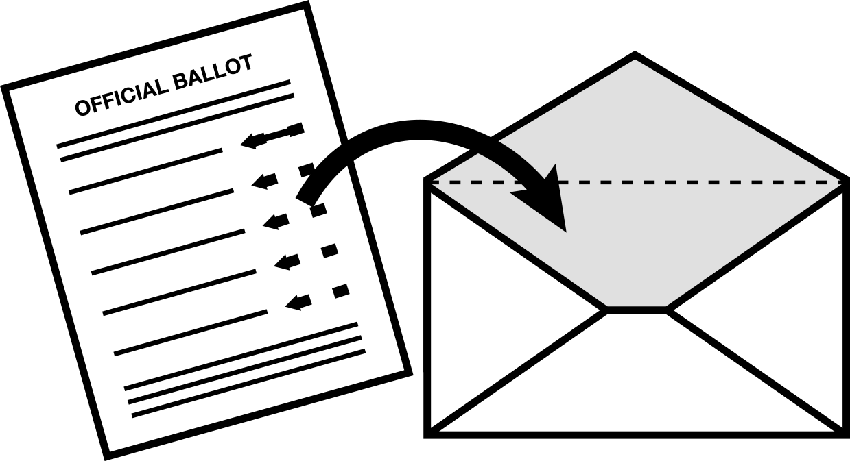 | Vote by mail  Request a vote-by-mail ballot by November 1.  Return it by mail, deliver it to the Registrar of Voters office, or drop it off at any polling place on Election Day.  Vote-by-mail ballots must be postmarked or delivered to a polling place by November 8  For more details, see page 3.

Vote early in person
You may vote early at two locations
October 11 - November 8
701 Ocean St., Room 210, Santa Cruz
Monday – Friday 8am to 5pm
Watsonville City Clerk’s Office
275 Main St., 4th Floor (6th floor of the parking garage)
Monday – Friday, 8am to 5pm
Both locations will also be open
Saturday and Sunday, November 5 & 6, 9am to 5pm
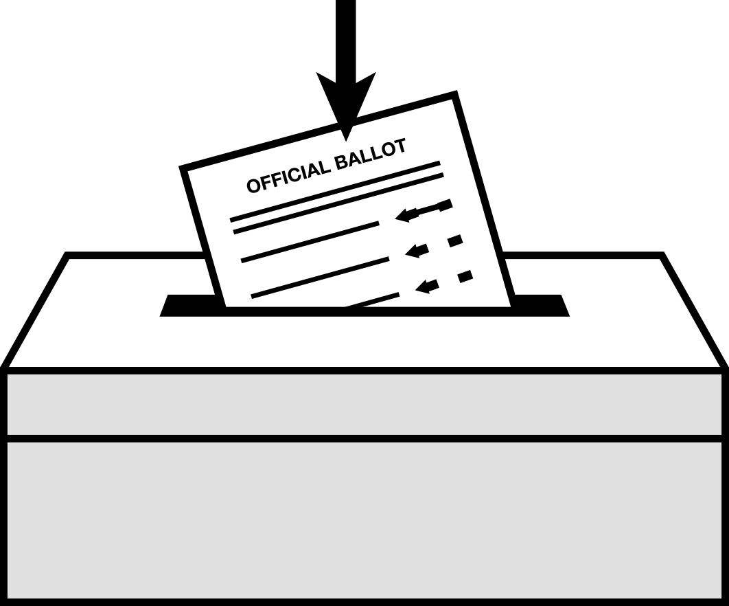 | Vote at the polls in person  Polls are open on Election Day:  November 8, from 7am to 8pm  The location of your polling place is printed on the back cover of this guide.  Or, you can look up your polling place:  - On the web: www.votescount.com  - Call the County Clerk’s office at 831-454-2060  For more details, see page 4 and 5.

How to vote by mail

You can vote by mail before Election Day
To vote by mail, you have to request a ballot. Then you can mark the ballot and send it back or drop it off at any polling place. You can vote by mail for this election only, or for all future elections.

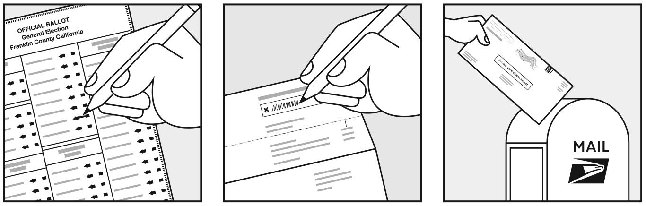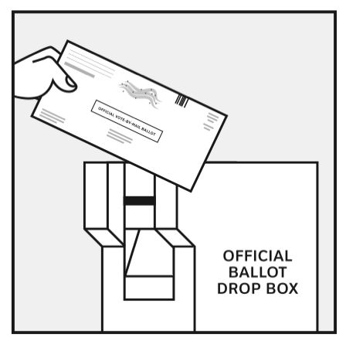

How to get your vote-by-mail ballot
You must request a vote-by-mail ballot by November 1.
You can:
Request a ballot at www.votescount.com
Use the application on the back of this booklet, and mail it or FAX it to 831-454-2445.
Call 831-454-2060.
After you apply to vote by mail, you will receive your ballot within one week.
Overseas voters, military personnel and their dependents can get a vote-by-mail ballot by asking your commanding officer, or go to: www.votescount.com

How to return your vote-by-mail ballot
Mark your ballot. Then follow the instructions on the official envelope to sign, date, and seal your ballot. You can:
Mail your ballot, so that it is postmarked by Election Day, November 8.
Hand deliver your ballot to the Santa Cruz County Clerk Elections or the Capitola, Santa Cruz, Scotts Valley or Watsonville City Clerk.
Drop it off at one of the 24/7 drop boxes located at:
- 701 Ocean Street, Santa Cruz, in front of the county building.
- 212 Church Street, Santa Cruz, public parking lot
- 1 Civic Center Drive, Scotts Valley City Hall parking lot
- 420 Capitola Avenue, Capitola City Hall parking lot
- 316 Rodriguez Street, Watsonville public parking lot 14
Drop off your ballot on Election Day at any polling place in Santa Cruz County.
How to vote with a paper ballot

At the polling place, you can choose to vote on a paper or touch screen ballot.

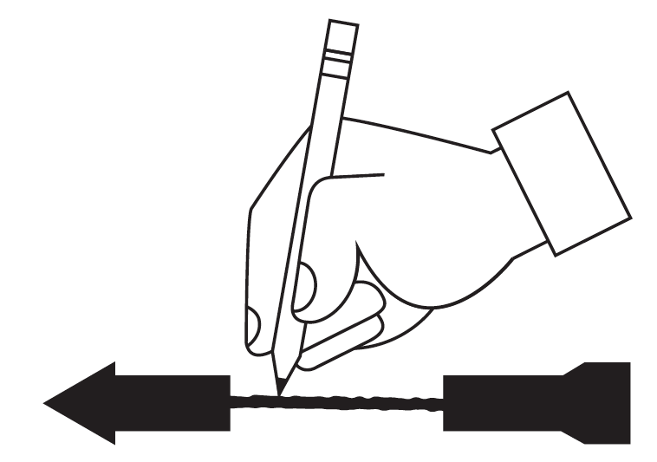
Mark your ballot
Draw a single line to connect the head and tail of the arrow that points to your choice.
Use only a blue or black ballpoint ink pen. Do not use red ink pens, Sharpies,
markers or any other type of pen.
Do not sign your name on your ballot, write your initials, or write any other words or marks on your voted ballot.
To vote for a qualified write-in candidate, write their name
on the blank line at the end of the list of candidates.
Then connect the arrow pointing to that name.
A list of qualified write-in candidates is available at the polling place on Election Day. The list is posted on our website at www.elections.ca.us 13 days before the election

Check your ballot carefully
If you make a mistake ask a poll worker for a new ballot or follow the instructions in your ballot packet.

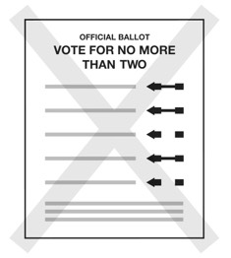
Don’t vote for too many
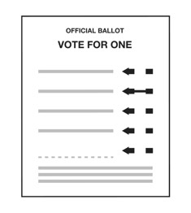
Vote for the number allowed.
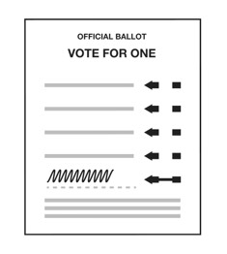
Always connect the arrow,
even on a write-in vote.

Cast your ballot at the scanner

After you have marked your ballot, take it to the scanner and insert your ballot.
If you made a mistake, such as voting for too many candidates, the scanner will eject your ballot so you can correct it.
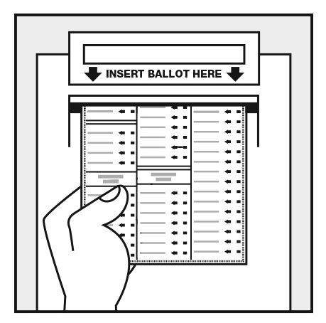

How to vote with an electronic ballot

At the polling place, you can choose to vote on a touch screen or paper ballot.
With touch screen voting, all voters – including those with disabilities – can vote privately and independently.
1. Tell the poll worker you want to use the touch screen  - The poll worker will give you a ticket.  - Take it to the touch screen area.  - When it’s your turn, a poll worker will activate the screen so you can vote. | 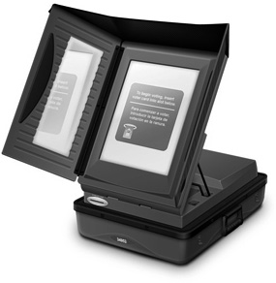
2. Mark your ballot  - Touch the box next to your choice. A green check mark will appear.  - To change your vote, touch that choice again. The green check mark will disappear.  - To vote for a write-in candidate, touch the box that says WRITE-IN. A keyboard will pop up. Type the write-in candidate’s name, then touch OK. | 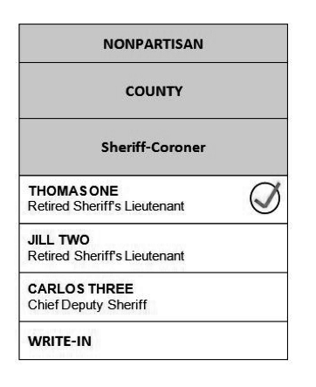
3. Review your votes  - Touch the screen to print and review a paper record of your votes.  - If you want to make changes, you can start again. | 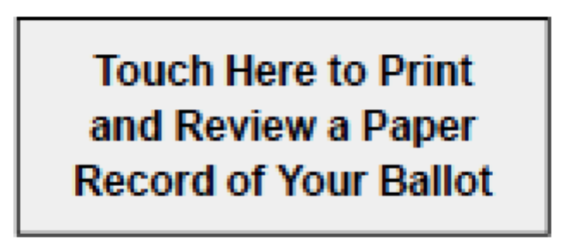
4. Cast your vote  - Touch the screen to cast your ballot.  - Protect your vote. Do not leave the voting system until you see the green “Thank you” screen that says your vote has been recorded. | 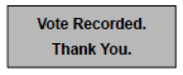

Accessible Voting

At the polling place
To check polling place accessibility, look for the wheelchair symbol on the back cover of this pamphlet. If your site is accessible, below the symbol you will find the word Yes.
In some polling places, temporary thresholds, ramps, signage, cones, and door props, are used to improve access to the facility.

Curbside voting
If your polling place is not accessible, you may vote on a paper or an electronic ballot from a nearby accessible location, including a car. A poll worker will qualify you to vote and return the voted ballot to the polling place.
To request curbside voting assistance, you can:
- call in advance to coordinate a time and place
- have an assistant make the request inside the polling place

Accessible voting system
Each polling place in the county has a touch screen voting system with:
- an audio option that reads the ballot to you
- a universal plug for personal assistive device
- large print (24 points)
- a choice of English or Spanish

A ride to your polling site
We can arrange to have an accessible van pick you up and take you to the polls to vote. Please call prior to Election Day to make an appointment.

Ballot delivery to your home
We can deliver a ballot to your home and return it to the Elections Department. Please call before Election Day so there will be enough time to provide assistance.

Voting information
Audio versions of the information about local measures and information printed in the State Voter Guide are available on request. The recordings are available approximately four weeks before the election.

How to request assistance
To request any of this options for assistance with accessible voting:
Phone Santa Cruz County: 831-454-2060
Disability Rights California will operate a statewide Election Day Hotline
7am to 8pm on Election Day: November 8, 2016
1-888-569-7955
TDD: 711

Who is on the ballot for this election?
In the November General Election, all voters receive the same ballot, no matter what political party you are registered with, or if you have no party preference. The address where you are registered to vote determines which contests are on your ballot.
In the June Primary Election, all Californians were able to vote to decide which candidates for federal and state offices moved on to the November General Election. Candidates for local county offices in June received enough votes to be elected without having to be in a run-off in November.
Presidential  Nominated by party | California Top-Two Primary  Nominated by voters | Local  Nonpartisan candidates
President and Vice President | - U.S. Senator  - U.S. Representative  - State Senator  - State Assembly Member | School District Offices  - Special District Offices  - Municipal Offices
The candidates nominated by each political party are on the ballot | The top two candidates–the ones with the most votes in June–are on your ballot. | Candidates for county offices on the ballot in June received at least 50% plus 1 vote in the Primary. So, they were elected and are not on the General Election ballot.
You can write-in a candidate for President and Vice President. | There is no write-in for these offices. | You can write-in a candidate for these offices.
The party nominating the candidate is listed with their name.  Candidates may be nominated by more than one party. | The candidates’ party preference (or “None”) is listed with their name.  Both candidates on the ballot may have the same party preference. | Candidates for nonpartisan offices do not have a party preference listed on the ballot.
For more information you can:
Call the Elections Department at 831-454-2060
Visit our website at www.votescount.com
Visit the California Secretary of State’s website at
www.sos.ca.gov/elections/primary-elections-california/

